Shabbos Stories for
Parshas tzav 5781
Volume 13, Issue 31 14 Nisan/March 27, 2021
Printed L’illuy nishmas Nechama bas R’ Noach, a”h

For a free subscription, please forward your request to keren18@juno.com
Past stories can be found on the website ShabbosStories.com

To Atone for the Unknown.

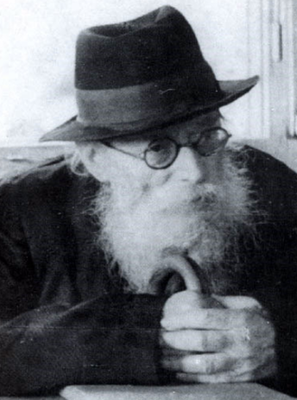

Reb Seroya Deblitsky came to the Chazon Ish, zt’l, and said that he wants to be matir neder, to annul a vow. There was another Yid in the room, speaking Torah with the Chazon Ish. The Chazon Ish said, “We’re two. Go outside and bring in a third person.”
Soon, Reb Deblitsky returned with an unlearned person, whose religious standards were also poor. The Chazon Ish asked Reb Deblitsky to state the reason he wanted to annul the vow, and then they annulled the vow.
When the unlearned man left the house, the Chazon Ish said, “Go outside and bring in someone else to be matir neder. This man wasn’t kosher for the beis din.” The Chazon Ish however didn’t say this earlier, so as not to embarrass the man.
Reb Deblitsky learned from this episode the middos of the Chazon Ish, and how cautious we must be not to hurt a fellow man.

The Tchebiner Rav and the Sefer Torah
A similar story happened with the Tchebiner Rav zt’l. At a hachnasas sefer Torah celebration, the owner of the sefer Torah honored the Tchebiner Rav to write a letter in the sefer Torah. The Tchebiner Rav said, “I’d rather appoint the sofer to be my shaliach to write a letter for me.”
After the sofer wrote the letter, the baal habayis honored another person to write a letter. This person followed the Tchebiner Rav’s lead and he also appointed the sofer to write the letter for him. Everyone else in the room also had the sofer write the letters for them.
The Tchebiner Rav explained that he realized that one of the people who came to the hachnasas sefer Torah celebration was halachically unfit to write a letter in the sefer Torah. But if he were to say anything, that person would be embarrassed. So the Tchebiner Rav appointed the sofer his shaliach to write a letter, and this caused everyone present to do the same. The sefer Torah was written according to halachah without having to embarrass another Yid.

The Chofetz Chaim’s Piece of Paper
The Chofetz Chaim zt’l once picked up a piece of paper from the ground because he thought it was sheimos. As it turned out, it was just a scrap of paper. The Chofetz Chaim placed the paper in his pocket.

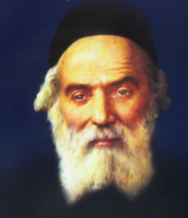

Someone walking with the Chofetz Chaim asked him, “Why don’t you just throw it to the ground? It isn’t sheimos.”
The Chofetz Chaim replied, “If I throw it down, the next Yid who passes by may pick it up, thinking that it’s sheimos. Why should I trouble him?”

The Lesson of a Partiular Tekiyos Shofar
I remember one Rosh Hashanah; my father said before tekiyos shofar with immense kavanah, as he would say it every year. The baal tokeyah finished saying the brachos, but when he tried blowing the shofar, no sound came forth. He kept trying, but to no avail.

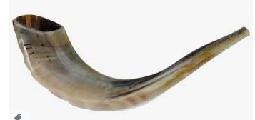
My father motioned that he should give him the shofar. My father tried blowing the shofar, and he also wasn’t able to blow it. Then my father gave the shofar to a third person, who blew the shofar easily.
I knew that my father didn’t know how to blow shofar, so after the davening I asked my father why he tried blowing the shofar. My father (Rav Alter Biderman of Lelov) replied, “I didn’t want the baal tokea to be embarrassed. If I would have given the shofar right away to someone who knows how to blow it, the first baal tokeia would feel ashamed. But after I also tried and failed to blow the shofar, his shame was less.”

The High School Girl’s Painful Rejection
There was a high-school girl who needed a spiritual boost, and she and her parents agreed that it would be best for her to change schools, so she could begin anew; this time, cautious to forge friendships with better girls. With the help of askanim, she was accepted into a high-school with a good reputation.
But on the first day she was in that school, four girls in her new class treated her unkindly. They disgraced and embarrassed her. That evening she told her parents that she is never returning to that school again, even if that meant remaining home.
The parents spoke with her previous school, and they agreed to take her back. Years later, all the girls in this story were married for several years, but none of them had children. The four girls (from the high-school) convened, and they concluded that they might be suffering because of the time when they disgraced the new girl who came to their high-school. One of the girls went to her, and requested her forgiveness in the name of all four women.

She Couldn’t Forgive Her Former Tormentors
She didn’t forgive. She said, “That incident happened thirteen years ago, and it still hurts me to even think about it. No, I definitely do not forgive you.”
Now, the four women were more convinced that this must be the explanation for their barrenness. The woman they harmed hadn’t yet forgiven them. They sent other shluchim to speak with her, and to ask her forgiveness, but she wasn’t appeased.
The four women decided to send their teacher (the teacher who would have been her teacher, had she remained in the school). The woman (who received the disgrace) had derech eretz for this teacher and agreed to listen to her. The teacher spoke with her about the importance of loving one’s fellow man, and learning to get along with people.
Finally, she consented and said, “O.K., I agree to meet with them, but on the condition that they don’t mention that time when they embarrassed me. It’s too painful for me to even think about it.”
The women met (in the home of the one who was disgraced). The four women came, each carrying a different delicacy in their hands. They ate together, and they spoke, as they were all cautious not to mention that time when they embarrassed her.
An hour passed, and then one of the four women said emotionally, “Take a look at what’s happening here. Five women, all waiting to finally hold their own child in their arms, while all their friends already have four or five children… Hashem! Please! Have rachmanus…”
And they all cried for a long time. When they finished crying, they felt very close. The woman who was disgraced said to them, “I forgive you.” They left to their homes, feeling relieved. A heavy stone was lifted off their hearts.
A year later, each of them had a child… We must be cautious not to harm anyone with words. And for those who were harmed and insulted, let them learn from this story to forgive. Their forgiveness may save them, and others, from much distress.

The Chida’s Story About the Incredible Rosh Hakahol
The Chida tells a story that happened with his Rebbe, the Or HaChaim HaKadosh: A wealthy, rosh hakahol (who was also very close to the government) once disrespectfully disgraced and embarrassed one of the rabbanim in his city. The Or HaChaim spoke with that rav, and advised him, for the sake of peace, to forgive the rosh hakahol for his unkind words.
The rosh hakahol replied, “You don’t have to speak with me about this, because the moment he spoke out against me, I had already forgiven him. The Zohar says that the sins of the Jewish people weigh heavily on the Shechinah and cause the Shechinah pain. Therefore, to save the Shechinah from distress, I immediately forgive those who sin against me, so the Shechinah shouldn’t have tzaar due to their sins.”
The Or HaChaim praised the rav immensely for this. The Chida writes that therefore, Chazal (Rosh Hashanah 17) say, when one forgives others, all of his sins are atoned for. The explanation is, if you are cautious to forgive others, because you don’t want the Shechinah to have tzaar from their sins, then your sins will be forgiven as well, so the Shechinah shouldn’t have tzaar from your sins, either. (Rabbi Elimelech Biderman)

Reprinted from the Parshat Vayikra 5781 email of whY I Matter, the parsha sheet of the Young Israel of Midwood (Brrooklyn) compiled by Reb Yididye Hirtenfeld.

The Chesed in the
Naming of a Daughter

The two oldest children of Rav Yosef Shalom Elyashiv, zt”l, received names from Rav Elyashiv’s side of the family. The oldest son Shlomo was named after Rav Elyashiv’s grandfather, the Leshem, and their second child, Batsheva Esther, was named after Rav Elyashiv’s grandmother, the Leshem’s wife.
One of the Elyashiv’s neighbors on Rechov Chanan, an elderly widow named Sarah Rochel Goldman, never had children, R”L. One day, Mrs. Goldman dejectedly said to Rebbetzin Elyashiv, “Shayna Chaya, when I pass on from this world, what will I leave behind? I will never have anyone named after me, as I have no children. There will be no remembrance of me at all.”
Rebbetzin Shayna Chaya was under 30 years old and expecting her third child at that time. Her empathy for her elderly neighbor was so deep that she went home crying. She and Rav Elyashiv decided that if this child was a daughter, they would name her Sarah Rochel. Although according to the Ashkenazi custom, a baby is not named after a living person, Rav Elyashiv felt that in this particular case, the Chesed of raising the spirits of the lonely widow took precedence over the custom.

The Older Woman’s Life is Invigorated
A short while later the baby was born, and it was a girl. Mrs. Goldman was elated to learn that the Elyashivs had named their newborn daughter in her honor. The baby brought new life to the older woman. Before every Yom Tov, she would visit and bring candy for her young namesake, along with apologies that she was unable to afford more expensive gifts.
One day, when Sarah Rochel Elyashiv was about 10 years old, she and her sister Batsheva met Mrs. Goldman, who was already past 80 years old. Mrs. Goldman asked the two girls to stand next to each other, and she observed that Sarah Rochel was slightly taller than her sister, who was a year and a half older. The old lady jokingly said, “I assume that Sarah Rochel is taller because she has one virtue that Batsheva doesn’t have. She was named after me!”

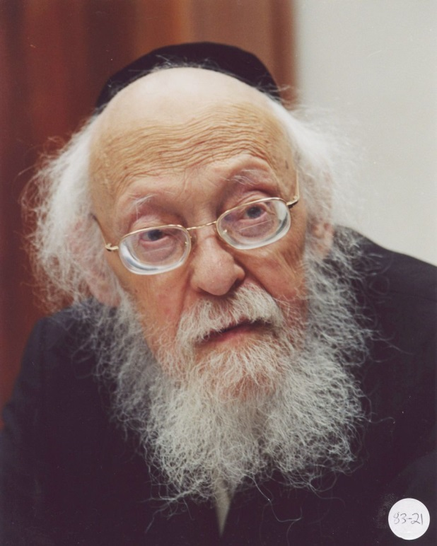

Mrs. Goldman passed away about two years later, right before the Bas Mitzvah of Sarah Rochel.

A Question to Her Father
Rebetzin Sarah Rachel (Elyashiv) Yisraelson once asked her father if he had any reservations about naming Sarah Rochel after Mrs. Goldman. After all, the woman was still alive when she was named in her honor, and Mrs. Goldman did have a very difficult life, and she was not Bentched with children.
Rav Elyashiv told his daughter, “If one does Chesed, no harm will befall them!”

Reprinted from the Parshas Vayikra 5781 email of Torah U’Tefilah as compiled by Rabbi Yehuda Winzelberg.
Rabbi Berkowitz’s Life-Saving “Good Night”

Rav Paysach Krohn tells the story of a slaughterhouse in Argentina that opened every day at 5:00 in the morning and closed at 6:00 in the evening. The owner, Zev, stayed until 8:00 every night, when he would turn off the lights, drive to the guardhouse, and say good night to Pedro, the security officer. Then, he and Pedro would leave, each in their own car.
One night, Zev stopped at the guardhouse as usual and said, “Time to go home, Pedro.”

The Guard’s Refusal to Leave
Pedro replied, “We can’t go. Rabbi Berkowitz, one of the Shochtim, hasn’t left yet.”
Zev asked, “How do you know he didn’t leave yet? It’s two hours after closing time.”
Zev doubted Pedro, but the guard was insistent. So, Zev and Pedro went back into the place to look for the missing Shochet. They unlocked the door to the huge walk-in freezer, and were stunned to see Rabbi Berkowitz, rolling around on the floor trying to keep himself warm. He had accidentally locked himself in the freezer, and no one had known about it.
After they helped Rabbi Berkowitz out and made sure he was not injured, Zev asked Pedro, “How did you know he hadn’t left yet?”

That Rabbi Makes Me Feel Important
Pedro responded, “That Rabbi always says good morning to me when he arrives, and every night before he leaves, he says, ‘Good night, have a pleasant evening.’ I wait for it every day, because almost no one else pays any attention to me. To them, I’m just the security guard. But Rabbi Berkowitz makes me feel important, and I wait for his good night blessing. I knew he was here this morning, and I knew that he hadn’t left yet.”
Rabbi Berkowitz’s nightly greeting to Pedro actually saved his life!

Reprinted from the Parshas Vayikra 5781 email of Torah U’Tefilah as compiled by Rabbi Yehuda Winzelberg.

The Distant Relative

A Jew was once in great distress, and he went from Tzadik to Tzadik for a Brachah. However, they all told him, that sadly, they couldn’t help him. He decided to a go to the Chozeh of Lublin for help.
When he entered the Chozeh’s room, he poured out his heart, and as he finished his story, he added, “Rebbe! We are related! The Rebbi's wife’s aunt's brother-in-law is a cousin of my wife! Please help me!”
He hoped that by saying they were related, the Chozeh would feel a stronger need to Daven for him. Nevertheless, the Chozeh replied, “It is true that we are related, but it’s too distant!”

His Last Hope was Devastated
The man walked out the room, and he was devastated. His last hope was shattered. As he left, he encountered one of the main students of the Chozeh, Reb Naftali, who later became the Rebbe of Ropshitz. Reb Naftali said to him, “Normally, whoever walks in to visit the Rebbe, comes out happy. How is it that you came to see him, and you are so distraught?”
The broken man explained everything to Reb Naftali, who listened intently. Then he told the man, “Come with me to the Shul. The Rebbe wall be coming shortly to Daven Minchah. Please follow my instructions, and everything will be ok.”
The man did as he was told, and when the Rebbe came into Shul, Reb Naftali called the man over. He said, “Go and stand behind the Rebbe when he Davens. When the Rebbe starts the quiet Shemoneh Esrei and says the words ‘Elokei Avraham’, 'The G-d of Avraham', whisper in his ear, ‘Too distant relative!' Do the same when the Rebbe says ‘Elokei Yitzhok’ and ‘Elokei Yaakov’”
The man followed the instructions and stood behind the Chozeh. When the Chozeh said ‘Elokei Avraham’, the man whispered in the Chozeh’s ear, “Too distant relative!” As the Chozeh said ’Elokei Yitzchak', the man whispered again, “Too distant relative!” And he repeated the same when he said ‘Elokei Yaakov'.

Who Gave You that Idea?
As soon as the Chozeh finished his Tefilah and took the three steps back, he turned around and called the man over. He said, “Tell me, who gave you that idea? It could only have been my student Naftali. But you know what? It touched my heart. I Davened for you, my son, and Baruch Hashem, you merited a salvation!” This story was once told over to the Brisker Rav, and the Brisker Rav replied, “This is a great story, but the fact is that the Chozeh of Lublin was actually right! A relative, the further away the relationship is, the more distant the relative they are. But when it comes to our Avos, Avraham, Yitzchak, and Yaakov, they will always remain our Grandfathers!”

Reprinted from the Parshas Vayikra 5781 email of Torah U’Tefilah as compiled by Rabbi Yehuda Winzelberg.

The Lesson of the
Lost Microchip

There was an amazing story told by powerofspeech.org about an eleven-year-old boy from Bet Shemesh who controlled his yetzer hara. One winter, his family went on a trip to Mount Hermon to see the snow, and he brought his pride and joy, his expensive digital camera.
The boy, Baruch, had such a passion for photography; he took 567 pictures on the mountain, and he was eager to upload them onto his computer. His little brothers were so excited to see the pictures, and they tried to look at the camera, but Baruch was emphatic that no one could touch it, and they had to wait for him to upload the pictures.
On the drive back home, Baruch fell asleep, and his precocious brother turned on the camera, and accidentally deleted all the pictures! Baruch woke up to his siblings panicking in the car, frantically trying to figure out how to get them back.
Baruch said, “It’s okay, I’ll be able to access the pictures from the memory card.” Unbeknownst to him, another one of his mischievous, but well-meaning, brothers had somehow gotten ahold of the camera back at Mount Hermon, opened it up, and left the mysterious little memory chip on the snowy parking lot at the bottom of the mountain.
To say that Baruch was angry when he found the memory card missing would be an incredible understatement. His anger towered over Mount Hermon, making it seem like an anthill.
Before he had a chance to react, his older sister Rivkah asked her father to pull over so she could talk to Baruch. Rivkah was kind, smart, and a role model to all her siblings. She was 27 years old and still waiting for her naseeb. Baruch’s father pulled over, and Rivkah took Baruch for a little walk on the side of the highway.
“Baruch,” she said, “I know you must be so frustrated and angry right now. But I once heard that if a person controls his anger, his yetzer hara, even if he’s 100% right, at that moment, he can ask Hashem for anything, and Hashem will look on him favorably.”

Instantly Calmed Down…And Made a Silent Wish
Baruch took a deep breath and thought of something he wanted. Instantly, he calmed down, and silently wished that in the zechut of controlling his anger, his sister should find her match. He got back in the car the picture of calm, while everyone looked at Rivkah and Baruch in amazement and appreciation.
Two weeks later, Baruch’s father received a call from an acquaintance, “Did you lose a memory card on Mount Hermon? An American yeshivah student, Eliezer, found it and started showing the pictures to a few people to see if he could track down the owner to return it, and I spotted your family.”
A few days later, Baruch and his father got into their car to drive to Jerusalem to get the memory card from this young man. Eliezer turned out to be just the perfect kind of boy for the wonderful Rivkah, and apparently Hashem agreed. Shortly after, Eliezer and Rivkah got married. The very memory chip that led Eliezer to Rivkah was a message for all of B’nei Yisrael. When we control our anger and our yetzer hara, even when we’re right, miracles will happen,
May we all realize that while the sacrifices we make for Hashem and our Torah can sometimes be very difficult, Hashem hand-picked these tests and difficulties for us to triumph over and grow stronger in our devotion to Him. We must know that these tests are ultimately for our benefit!

Reprinted from the Parshat Vayikra 5781 email of Rabbi Amram Sananes as written by Jack Rahmey
Trying to Reach the Right Person for the Entry Permits

Who does not need money before the Chag? The more a person sets aside for his expenses, the more his expenses become, especially if he needs clothes and shoes and extra food for the holiday. I [recently] met a friend who told me he was trying to get a couple into the country for their son’s wedding, but it is very difficult. Entry is barred to a nonresident.
He told me that this was so important to them, they were willing to give a large sum of money to whoever could get them in. The amount offered could make Pesach for five families.
First, I davened to Hashem that if this was for me, He should help me find a way and I not try for nothing. Then I called people I knew to find out how to get the couple into the country. After a day-and-a-half of calls, I knew what had to be done, but I could not connect with the right person.
Again, I davened to Hashem to help me. About five minutes later, I met a friend who whenever we meet, we share divrei Torah on the parsha, and I remembered that he is connected and I asked for his help. He connected me with someone who connected me with someone else and the ball started rolling.

Frustrated by the Challenges
I had to connect with a certain person. This took another two days. I was frustrated by the challenges and not seeing results and on the other hand, I needed the money. I went to daven Mincha and stayed after to learn. I davened to the Creator and asked, if I am to get the money then let it come already and if not, then please help me prepare for Yom Tov without much effort.
From there I went to wash the car and I began to talk to another customer there. His name was the same as the one who was supposed to help me. I asked him if he knew him, and he told me they are cousins. When he heard the issue, he told me his cousin was not the person to speak to and he gave me the name of someone who can take care of it in one moment.
I was amazed at the hashgacha, as I never thought I would make a connection at a carwash. He called the man and asked him to help me. He approved the permits and everyone was jubilant. He asked for nothing in return and would not take anything offered. He just wanted to help another Jew.

Reprinted from the Parshas Vayikra 5781 email of Tiv Hakehila.
A Meal for 18 Strangers
From the desk of Yerachmiel Tilles

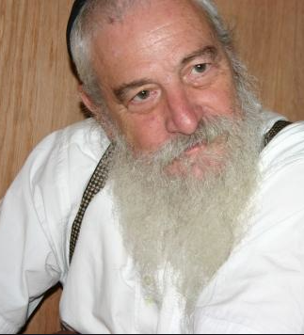
Yerachmiel Tilles

One day, Yaakov Rechimi (the grandson of Rabbi Michael Peretz of Mexico), received a phone call from a man who wanted to invite him to a seudat hodaya, a thanksgiving celebration that one hosts when one experiences a miracle. The caller told him his name, which community he belonged to, and which synagogue. Yaakov thought he recognized the name, but he didn’t really know the person and wasn’t sure why he was invited.
Still, he said: “Of course, you invite me to a seudat hodaya, I will come. What is it that you want to thank HaShem for and celebrate with a meal?”
The caller tells him, “I almost passed away. One month I was in the hospital with Corona; I almost died. But I survived, thank G-d, so now I want to make a seudat hodaya.”
So Rechimi said: “Of course I’ll come,” even though he still wasn’t sure why he was invited. When he arrived at the host’s home, he saw 17 other men were also present for the celebration meal. The 18 people including himself were a random group; each man was from a different shul, a different community, a different area. It just didn’t click for him why this specific group of 18 people were there.
He remarked to the person next to him: “It’s so nice that he invited us to his celebration.” They started talking and the other man tells him that he has no idea why he was invited; he doesn’t know the person who is making the seuda. “I got a phone call,” he shrugged, “so I came.” Rechimi told him “Yes, the same thing with me. I don’t know why I was invited, but I’m here.”
It turned out that all 18 at the table didn’t know why he was invited and was puzzled. Then, the person who the miracle happened to, who appeared to be about 60 years old, stood up and started speaking.

The Reason for Their Invitations
“I know you all want to know the reason why I invited you. I’ll tell you what happened. “When I was lying in the hospital, basically dead from the Corona, I felt myself rising up to Heaven. The first one I saw there was my mother, who had passed away a few years before.
“She exclaimed, ‘What are you doing here?! Go back down!’ ““I answered her, “Ma, I want to go back down but I can’t.” “My mother waved off my answer. ’No, you can go down. You want to know why? Look down there -- just take a look!’
“So I look down and what did I see? I saw all of you that I invited to this meal. You were in 18 different places but I saw you all in one glance while I was in Heaven. I saw you sitting saying tehilim (Psalms) for me. In fact, at that moment every single one of you was mentioning my name and my mother’s name. Even though you had no clue who I was, you mentioned my name and recited tehilim for my complete recovery.
“My mother then said to me ‘You see, they are giving you the power to come back alive.’ “And that’s what happened and that’s why invited every single one of you 18 people to the seuda. Because while I was in Heaven, I saw you saying tehilim for me and saving my life.”

Source: Rewritten by Yerachmiel Tilles from the report (transcribed by Mrs. Chaya Benami) of Rabbi Peretz about the NDE experience of his grandson. Connection: Weekly Readings – this week: Vayikra is completely devoted to describing (nearly) all the different kinds of offerings in the Holy Temple, including various forms of the Shelamim/Peace Offerings; Next week: Tzav provides the details of the Thanksgiving Offering (Levit. 7:11-15), which is one form of the Peace offering.

Reprinted from the Parshat Vayikra 5781 email of KabbalaOnline.org, a project of Ascent of Safed.

The Rebbe’s Advice
To the Parents of an
Off-the-Path Son
By Daniel Keren

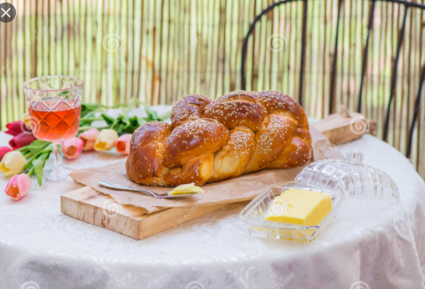

The following story was heard recently on Shabbos Parshas Vayakhel-Pekudei 5781 at the Bris Avrohom Shul in Hillside, New Jersey by the rav – Rabbi Mordechi Kanelsky. He noted the importance in that week’s Torah reading of observing and celebrating Shabbos properly.
He recalled a story that happened perhaps 40 years ago. One of the greatest heartbreaks for parents of a child raised in a frum (religious) home is when one of the children rebels and goes off the derech (off the path of leading a life based on our holy and traditional Torah values.)
Nothing the mother or father could say or do had any influence on the teenage boy. In quick succession, he took off his kipa from his head, dropped out of yeshiva, started dressing in the latest fashions of the secular world, began eating traif (non-kosher food,) stopped observing Shabbos and to emphasize his rejection of his parent’s “out-dated” values moved out of their home in the Crown Heights section of Brooklyn and moved to an apartment with other defiant youth in Manhattan.

The Completely Devastated Parents
Completely devastated the parents wrote in to the Lubavitcher Rebbe (Rabbi Menachem Mendel Schneerson, zt”l) for any advice and hope on reaching out successfully to their rebellious son.
The quick response from their world renowned Jewish spiritual leader left them shaking their heads. Instead of proposing a scheme to attract their son’s attention or a spiritual plan of reciting particular Tehillim (chapters of Psalms) or some similar scheme; the Rebbe simple wrote back that they should improve the quality of their Shabbos Sedah.
Not knowing what this could do to bring back their son, they nevertheless as devoted chassidim of the Lubavitcher Rebbe decided to act upon his strange advice.

The Mother’s Question to Each Child
That week a couple of days before Shabbos, the mother went to each of the children and asked them if they had a particular favorite dish that they might like to eat for the Shabbos meal, the perplexed children gave seemingly outlandish suggestions. One child asked for roasted duck. Another child was more simple and wanted spaghetti and meatballs. Yet another child wanted a fancy desert – lemon moraine pie.
And that Shabbos, the children were shocked to their cores when their mother brought out to each child the special dish that had been requested.

A Two-Hour Nap to Be Rested for Shabbos
Not only that, but the father who was accustomed to rushing home an hour before candlelight and getting into his special Shabbos kapota (Chassidic suit) and going to the mikva before arriving in shul with just minutes to spare, came home a few hours earlier that Shabbos. He took a two-hour nap so that he could be rested for the Shabbos meal.
So instead of falling asleep at the meal, the father was wide awake. The children were further surprised when their father who had usually rushed the meal, asked each child if they had a particular song or nigun that they would like to have sung. The mother asked each child if they had a particular dvar Torah or Torah insight they would like to share with the family.

Again the Children were Flabbergasted
The next week, the children were absolutely flabbergasted when the mother again approached them individually to inquire what special dish they would like her to prepare.
And this continued for the next few weeks. What had previously been a rote 30-minute excuse of a Shabbos meal turned into a delightful two-hour celebration that everyone in the family enjoyed and looked forward to.
About a month after this transformation of the Shabbos seudah (meal), the rebellious son called home to talk to one of his siblings. He was told about what happened and how the mother really cared about what each child wanted to eat and how the father wanted to sing the children’s favorite Shabbos songs and hear their Divrei Torah. Shabbos had become a fantastic experience.
The off-the-derech son was shocked and thought to himself that he had to see this for himself. It happened to be Friday afternoon shortly before candle lighting when he had made his phone call.

Travels on the Subway on Shabbos
He immediately hopped onto a subway train without a kipa and dressed like a non-religious teenager travelled on the Shabbos. When he knocked on his family’s door, him mother and father cheerfully invited him in. His mother apologized for not having asked him before Shabbos for his favorite dish. She asked him what he would like her to prepare for the next Shabbos. After that meal, he left and took the subway back to his Manhattan apartment.
That Shabbos experienced not only had transformed the parents and the siblings, but it also began to affect the neshama of the rebellious son. After a few weeks, he started coming in time before Shabbos and again began wearing a kipa and the clothing of a frum Jew and stopped eating traif. Shortly thereafter, he moved back into the family home and resumed learning in Yeshiva. Such is the power of a beautiful Shabbos meal.

